**AI Project Submission – Phase 2: Mid-Implementation Report**

**1. Project Title**

Feedback Generator for Student Portfolio

**2. Team Members**

| **Name** | **Registration No.** | **Section** | **Email** |
| --- | --- | --- | --- |
| **Hafsa** | F2022266064 | V-8 |  |
| Naeem |  |  |  |

**3. Summary of Phase 1**

Students often submit portfolios that include their academic records, projects, skills, and other achievements. Writing personalized, consistent, and constructive feedback for each student is time-consuming for instructors. This project aims to solve that by using a generative AI model to produce short, structured, and relevant feedback automatically based on the student portfolio input.

**4. Work Completed So Far**

* Designed prompt for structured feedback output
* Implemented generate_feedback() using OpenRouter’s GPT-style model mistralai/devstral-small:free
* Integrated API into a Tkinter-based GUI
* GUI includes input field, output field, and styling
* Validated output for multiple test cases (excellent, average, poor portfolios)

**5. Screenshots and Code Snippets**

**Code :**

import openai

import tkinter as tk

from tkinter import messagebox, scrolledtext

# ✅ OpenRouter API Setup

openai.api_key = "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"

openai.api_base = "https://openrouter.ai/api/v1"

def generate_feedback(portfolio_text):

prompt = f"""You are a professional academic evaluator.

The following is a student's portfolio:

\"\"\"{portfolio_text}\"\"\"

Based on this, give a short structured evaluation in the exact format below:

Eligibility: [Write one of the following - Excellent, Good, Satisfactory, Needs Attention]

Lackments:

- [Mention 1–2 weaknesses or areas for improvement, or write 'None' if perfect]

Regards: [Write a suitable closing based on eligibility like 'Outstanding work', 'Needs improvement', 'Good effort', or 'Best of luck']

Do not write any extra sentences or paragraphs. Follow only the structure.

At last give a one line concise rewiew

"""

try:

response = openai.ChatCompletion.create(

model="mistralai/devstral-small:free",

messages=[{"role": "user", "content": prompt}],

max_tokens=300,

temperature=0.6

)

return response.choices[0].message.content.strip()

except Exception as e:

return f"❌ Error: {e}"

# ✅ GUI Function

def on_generate():

input_text = input_box.get("1.0", tk.END).strip()

if not input_text:

messagebox.showwarning("Empty Input", "Please paste the student portfolio content.")

return

output_box.delete("1.0", tk.END)

output_box.insert(tk.END, "⏳ Generating feedback...\n")

window.update_idletasks()

feedback = generate_feedback(input_text)

output_box.delete("1.0", tk.END)

output_box.insert(tk.END, feedback)

# ✅ GUI Setup

window = tk.Tk()

window.title("Student Portfolio Feedback Generator")

window.geometry("500x700")

window.config(bg="#f2f2f2")

tk.Label(window, text="📄 Enter Student Portfolio Content:", font=("Segoe UI", 12, "bold"), bg="#f2f2f2").pack(pady=(10, 0))

input_box = scrolledtext.ScrolledText(window, font=("Segoe UI", 11), width=95, height=12, wrap=tk.WORD)

input_box.pack(padx=10, pady=10)

generate_btn = tk.Button(window, text="✨ Generate Feedback", font=("Segoe UI", 12), bg="#4CAF50", fg="white", command=on_generate)

generate_btn.pack(pady=10)

tk.Label(window, text="🧾 Generated Feedback:", font=("Segoe UI", 12, "bold"), bg="#f2f2f2").pack(pady=(15, 0))

output_box = scrolledtext.ScrolledText(window, font=("Segoe UI", 11), width=95, height=10, wrap=tk.WORD)

output_box.pack(padx=10, pady=10)

window.mainloop()

**Screen Shots**

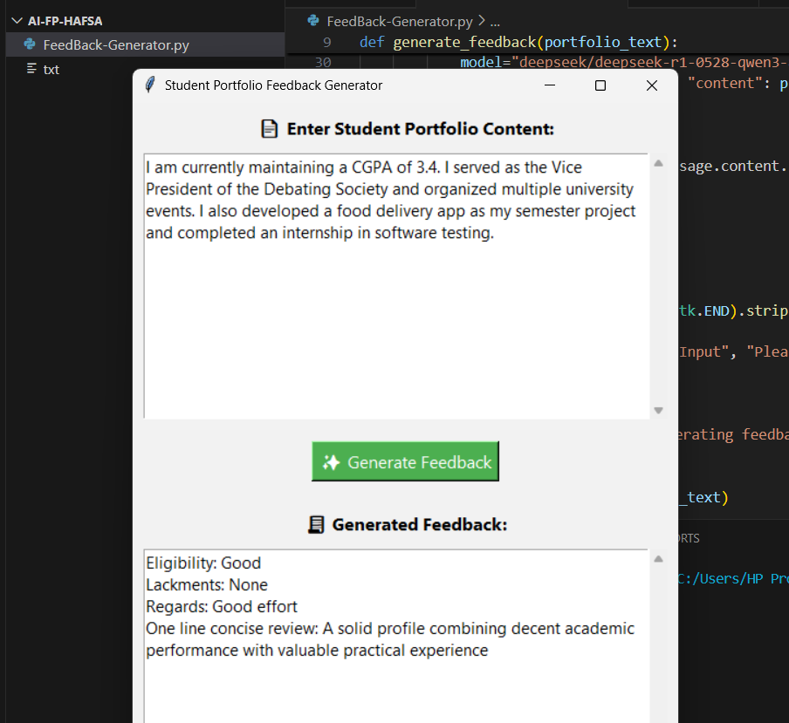

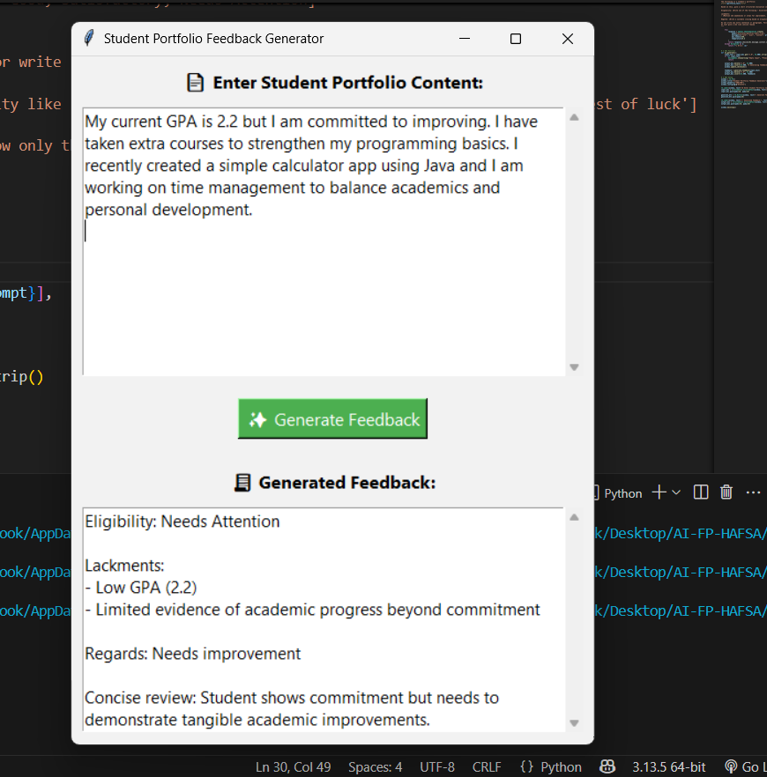

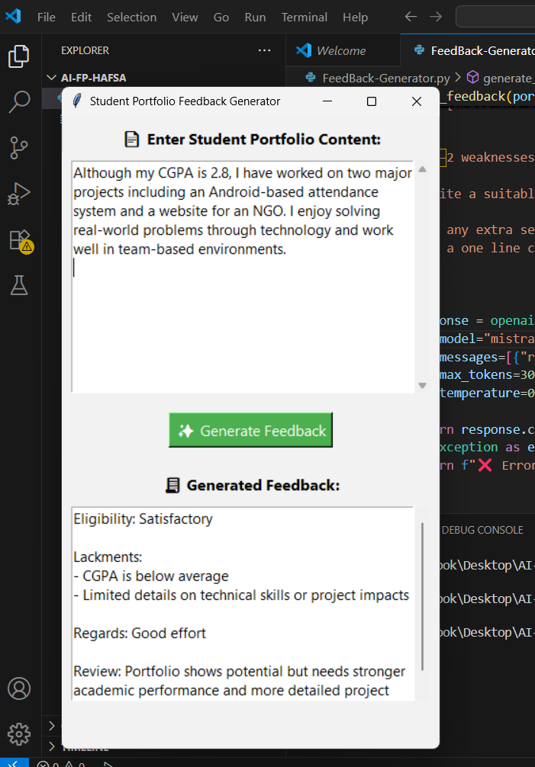

**6. Tools Used So Far**

* Python 3.11
* OpenRouter API (Generative LLM)
* Tkinter for GUI
* Regex (planned for fallback cleaning if needed)
* openai Python library for API requests
* tkinter.scrolledtext for scrollable input/output
* re (regex module) for response formatting (planned)

**7. Problems Faced**

* Output was initially paragraph-based; refined prompt for bullet format
* Token limit and incomplete answers fixed with max_tokens=300
* API credit issues resolved by switching keys/models

**8. Planned Improvements**

* Add button to export feedback to .txt
* Add language toggle (English / Urdu)

**9. Timeline Review**

| **Week** | **Planned Task** | **Status** |
| --- | --- | --- |
| 3--4 | Design + prompt tuning | ✅ Done |
| 5--6 | AI logic + GUI implementation | ✅ Done |
| 7--8 | Output format control, testing | ⏳ In Progress |

**10. Instructor Comments / Feedback (To be filled by evaluator)**

*__________________________________________________*

*__________________________________________________*

*__________________________________________________*